💰 AI Smart Budget Agent (Groq-Powered)

Project Overview:
An AI agent that:
- Accepts PhonePe transaction statements (CSV/PDF)
- Extracts and analyzes expenses
- Categorizes spending (Food, Travel, Bills, etc.)
This project builds an AI-powered Smart Budget Agent that:
- Reads 6 months PhonePe statements (PDF)
- Extracts transaction data
- Categorizes spending
- Generates AI-based budget plans using Groq LLM
  - Generate insights
  - Suggest budget plans
  - Detect overspending
  - Provide saving tips

Objectives:
- Automate financial data analysis
- Identify spending patterns
- Provide category-wise insights
- Generate personalized budget plans
- Suggest savings strategies using AI

Technologies Used:
- Python
- Streamlit (UI)
- Pandas (data processing)
- Groq API (LLM reasoning)
- Matplotlib / Plotly (optional charts)
- PDF/CSV parser

System Architecture:
User Upload PDF
↓
PDF Parser
↓
Data Cleaning
↓
Categorization Engine
↓
Analytics Engine
↓
Groq AI Agent
↓
Streamlit Dashboard

Project Structure:
smart_budget_agent/
│
├── app.py
├── parser.py
├── analyzer.py
├── categories.py
├── charts.py
├── agent.py
├── requirements.txt
Step 1: Get Groq API Key:
- Go to: https://console.groq.com/
- Create API Key
- Save it
Step 2: Install Dependencies:
pip install streamlit pandas groq matplotlib
Step 3: Sample PhonePe Data Format (CSV):
Your CSV should look like:
Date,Description,Amount,Type
2026-01-10,Swiggy Food,-250,Debit
2026-01-11,Salary,25000,Credit
2026-01-12,Uber Ride,-120,Debit

Code Implimentation:

app.py:
import streamlit as st
from parser import extract_transactions
from analyzer import analyze
from charts import plot_category
from agent import get_budget_plan

st.title("💰 AI Smart Budget Agent")

uploaded_file = st.file_uploader("Upload PhonePe PDF", type=["pdf"])

if uploaded_file:
# ✅ Step 1: Extract data
df = extract_transactions(uploaded_file)

# 🔍 DEBUG
st.write("DEBUG RAW DATA:", df.head(20))

# ✅ Step 2: Analyze
total_spent, total_received, summary, full_df = analyze(df)

# 🔍 DEBUG
st.write("DEBUG SUMMARY:", summary)

# ✅ Step 3: Overview
st.subheader("📊 Overview")
col1, col2, col3 = st.columns(3)

col1.metric("Total Spent", f"₹{total_spent:,.0f}")
col2.metric("Total Received", f"₹{total_received:,.0f}")
col3.metric("Transactions", len(full_df))

# ✅ Step 4: Category Chart (Streamlit built-in)
st.subheader("📂 Category-wise Spending")
st.bar_chart(summary)

# ✅ Step 5: Matplotlib Chart
st.subheader("📈 Chart")
fig = plot_category(summary)

if fig:
st.pyplot(fig)
else:
st.warning("⚠️ No expense data found in PDF")

# ✅ Step 6: AI Budget Plan
if st.button("Generate AI Budget Plan"):
with st.spinner("AI analyzing..."):
advice = get_budget_plan(summary.to_string())
st.subheader("🤖 AI Suggestions")
st.write(advice)

agent.py:
from groq import Groq
from dotenv import load_dotenv
import os

load_dotenv()

def get_budget_plan(summary):
client = Groq(
api_key=os.getenv("GROQ_API_KEY")
)
prompt = f"""
You are a financial advisor AI.

Here is user's spending summary:
{summary}

Generate:
1. Spending analysis
2. Overspending categories
3. Monthly budget plan
4. Money saving tips
5. Risk alerts (if any)
"""
response = client.chat.completions.create(
model="openai/gpt-oss-120b",
messages=[{"role": "user", "content": prompt}]
)

return response.choices[0].message.content

parser.py:
import pdfplumber
import pandas as pd
import re

def extract_transactions(pdf_file):
data = []

with pdfplumber.open(pdf_file) as pdf:
for page in pdf.pages:
text = page.extract_text()

if not text:
continue

lines = text.split("\n")

for line in lines:
# Extract ₹ amount
match = re.search(r'₹\s?([\d,]+\.?\d*)', line)

if match:
amount = float(match.group(1).replace(",", ""))

line_lower = line.lower()

# ✅ Smart detection
if "cr" in line_lower or "credited" in line_lower or "received" in line_lower:
amount = amount # income
elif "dr" in line_lower or "debited" in line_lower or "paid" in line_lower:
amount = -amount # expense
else:
# fallback → assume expense
amount = -amount

data.append([line, amount])

df = pd.DataFrame(data, columns=["Description", "Amount"])
return df

analyzer.py
import pandas as pd
from categories import categorize

def analyze(df):
df["Category"] = df["Description"].apply(categorize)

expenses = df[df["Amount"] < 0]
income = df[df["Amount"] > 0]

total_spent = abs(expenses["Amount"].sum())
total_received = income["Amount"].sum()

category_summary = abs(expenses.groupby("Category")["Amount"].sum())

return total_spent, total_received, category_summary, df

categories.py
def categorize(desc):
desc = desc.lower()

if any(x in desc for x in ["swiggy", "zomato"]):
return "Food"
elif any(x in desc for x in ["uber", "ola"]):
return "Transport"
elif any(x in desc for x in ["amazon", "flipkart"]):
return "Shopping"
elif "rent" in desc:
return "Rent"
elif "bill" in desc:
return "Bills"
elif "emi" in desc:
return "Loan & EMI"
else:
return "Others"

charts.py:
import matplotlib.pyplot as plt

def plot_category(summary):
if summary.empty:
return None # prevent crash

summary.plot(kind='bar')
plt.title("Category-wise Spending")
plt.ylabel("Amount")
return plt

Installation Steps (CMD):
Create folder in d: smart_budget_agent
- D:
- cd smart_budget_agent
- python -m venv myvenv
- myvenv\Scripts\activate
- pip install streamlit pandas groq pdfplumber matplotlib
- streamlit run app.py

Challenges Faced:
- No Expense Data (₹0 issue):
- Parser didn’t detect debits
- Fixed using negative assignment
- Empty Chart Error:
- IndexError: index 0 is out of bounds
✔ Fixed by checking summary.empty
- Groq Model Error:
model decommissioned
✔ Fixed using: openai/gpt-oss-120b

Output:
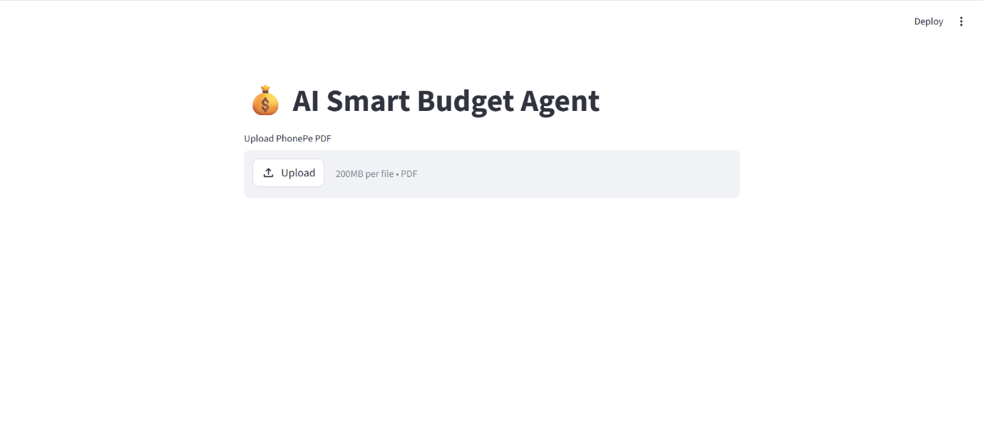
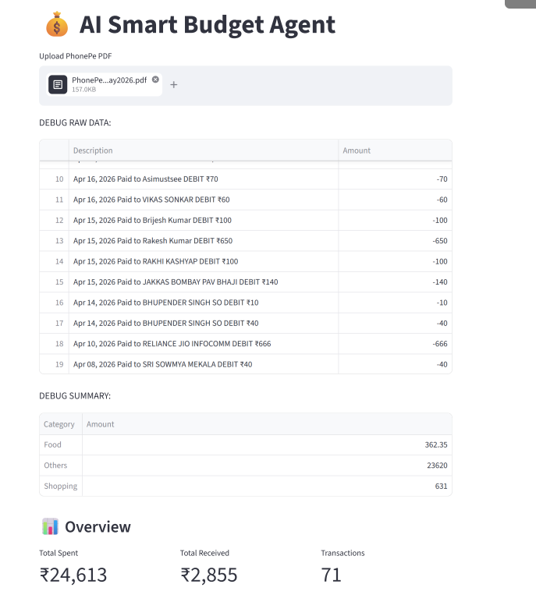
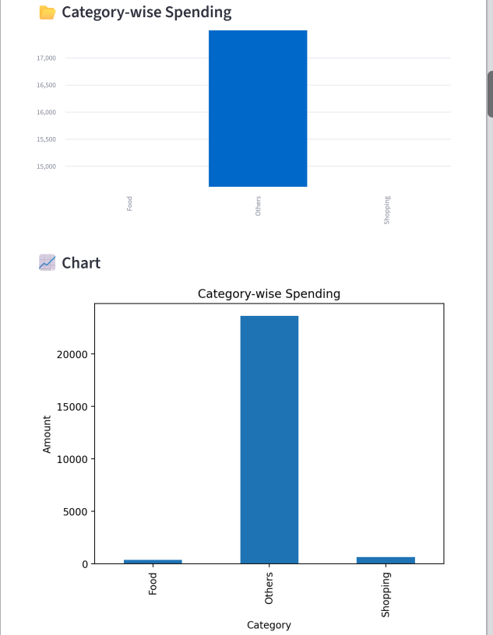
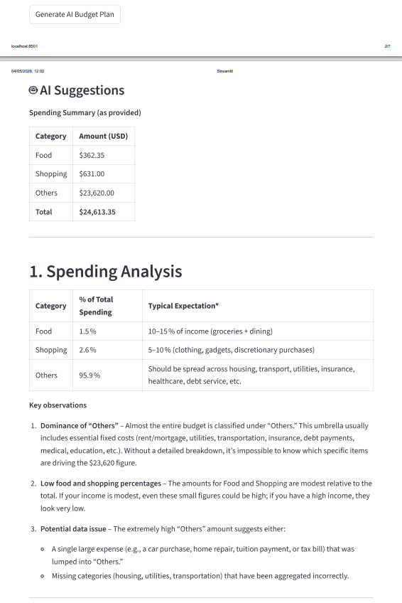
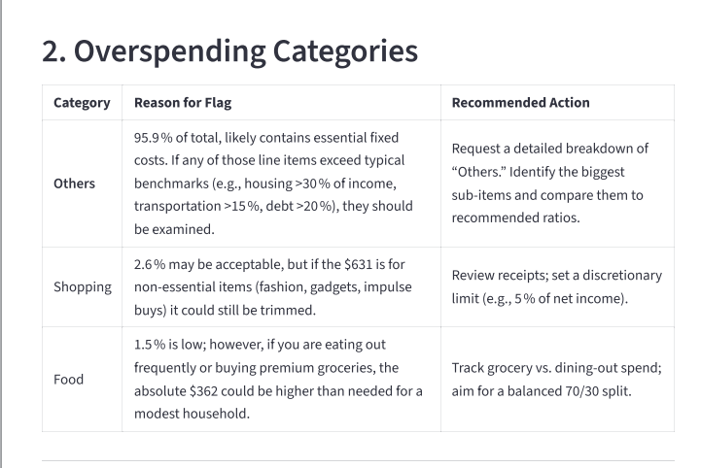
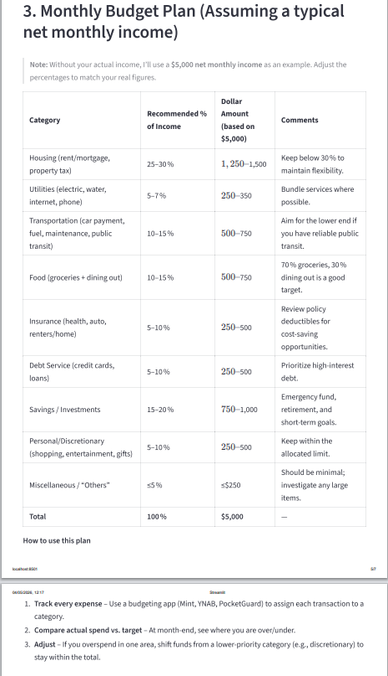
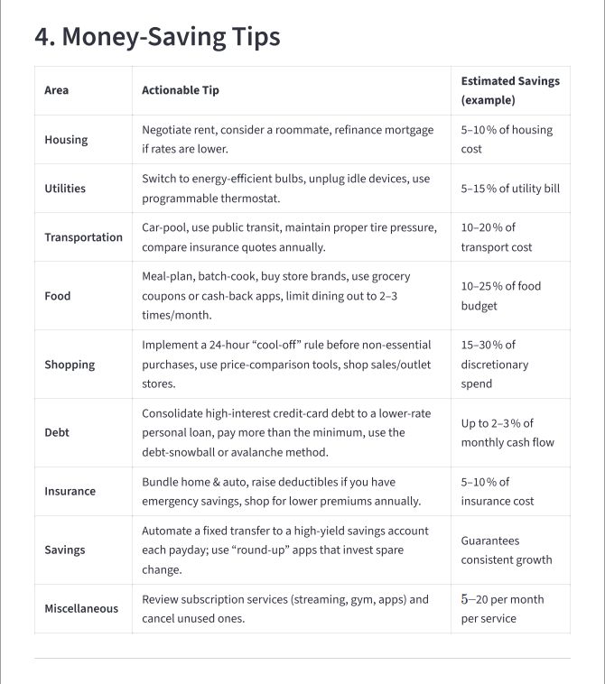
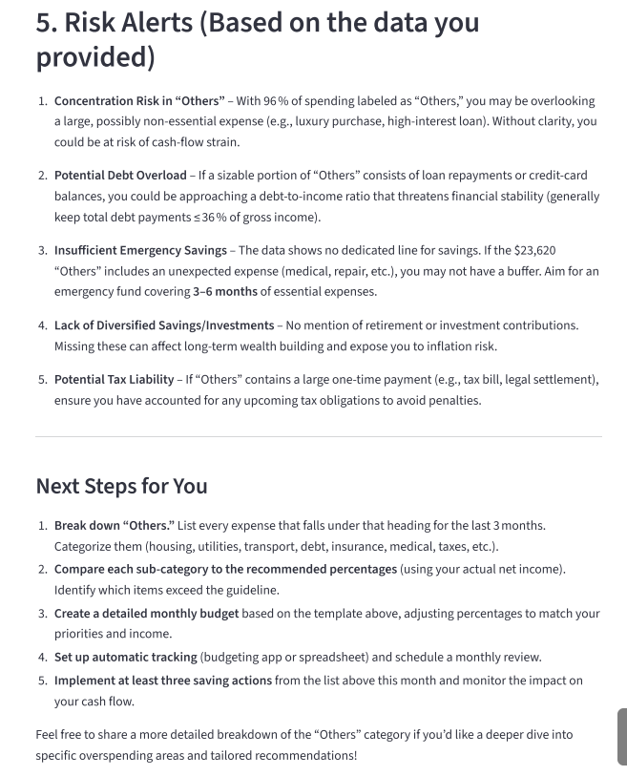

Conclusion:
This project successfully demonstrates:
- Real-world financial data processing
- AI integration using Groq
- Intelligent budgeting system
It helps users:
- Understand spending behavior
- Improve savings
- Make better financial decisions

